THIRD GRADE HOMEWORK
WEEK Of February 29, 2016
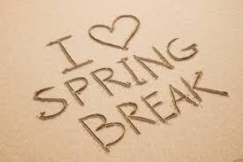
MATH- Pages 97-98 and 30 minutes of Think Through Math!

SPELLING- Packet pages 152-155

READING – Read 20 minutes from your assigned Literature Circle books

Spring Break is next week, so make this week count!

FOCUS WORDS: untied, repay, disagree, preheat, unafraid, return, preschool, dislike, disappear, resell, precook, prepay, unbeaten, reprint, unwrap

VOCABULARY WORDS: characteristic, cherish, expand, edible

CONTENT AREA WORDS:
expository, simile, metaphor, idiom, volume, ounces, pounds, grams

Neatness counts
Names & Dates on paper
Work is checked,
in binder, and ready
to turn in
Friday!

